**NAME :** Sachin Jadhav

**ROLL NO :** TEAD21151

**SUBJECT :** CN

**CLASS :** TE

**BRANCH :** AI&DS

**EXPERIMENT NO :5**

**TITLE :**

**Socket Programming using Python/C/C++/Java.**

**a. TCP Client, TCP Server.**

**b. UDP Client, UDP Server.**

**CODE:**

**a.TCP Client, TCP Server.**

**@server.py**

**import socket**

**import time**

**# create a socket object**

**serversocket = socket.socket(socket.AF_INET, socket.SOCK_STREAM)**

**# get local machine name**

**host = socket.gethostname()**

**port = 9999**

**# bind to the port**

**serversocket.bind((host, port))**

**# queue up to 5 requests**

**serversocket.listen(5)**

**while True:**

**# establish a connection**

**clientsocket,addr = serversocket.accept()**

**print("Got a connection from %s" % str(addr))**

**currentTime = time.ctime(time.time()) + "\r\n"**

**clientsocket.send(currentTime.encode('ascii'))**

**clientsocket.close()**

**@client.py**

**import socket**

**# create a socket object**

**s = socket.socket(socket.AF_INET, socket.SOCK_STREAM)**

**# get local machine name**

**host = socket.gethostname()**

**port = 9999**

**# connection to hostname on the port.**

**s.connect((host, port))**

**# Receive no more than 1024 bytes**

**tm = s.recv(1024)**

**s.close()**

**print("The time got from the server is %s" % tm.decode('ascii'))**

**b.UDP Client, UDP Server.**

**@Server.py**

**import socket**

**localIP = "127.0.0.1"**

**localPort = 20001**

**bufferSize = 1024**

**msgFromServer = "Hello UDP Client"**

**bytesToSend = str.encode(msgFromServer)**

**# Create a datagram socket**

**UDPServerSocket = socket.socket(family=socket.AF_INET, type=socket.SOCK_DGRAM)**

**# Bind to address and ip**

**UDPServerSocket.bind((localIP, localPort))**

**print("UDP server up and listening")**

**# Listen for incoming datagrams**

**while(True):**

**bytesAddressPair = UDPServerSocket.recvfrom(bufferSize)**

**message = bytesAddressPair[0]**

**address = bytesAddressPair[1]**

**clientMsg = "Message from Client:{}".format(message)**

**clientIP = "Client IP Address:{}".format(address)**

**print(clientMsg)**

**print(clientIP)**

**# Sending a reply to client**

**UDPServerSocket.sendto(bytesToSend, address)**

**@client.py**

**import socket**

**msgFromClient = "Hello UDP Server"**

**bytesToSend = str.encode(msgFromClient)**

**serverAddressPort = ("127.0.0.1", 20001)**

**bufferSize = 1024**

**# Create a UDP socket at client side**

**UDPClientSocket = socket.socket(family=socket.AF_INET, type=socket.SOCK_DGRAM)**

**# Send to server using created UDP socket**

**UDPClientSocket.sendto(bytesToSend, serverAddressPort)**

**msgFromServer = UDPClientSocket.recvfrom(bufferSize)**

**msg = "Message from Server {}".format(msgFromServer[0])**

**print(msg)**

**OUTPUT:**

**a.TCP Client, TCP Server.**

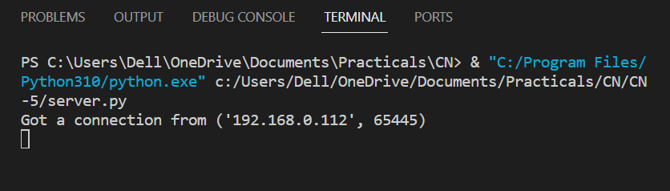

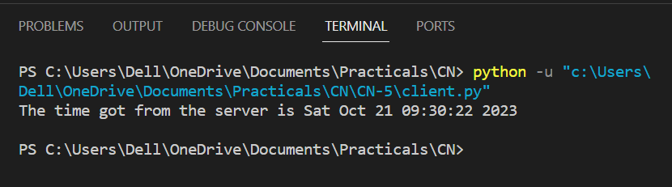

**b.UDP Client, UDP Server.**

